**ASSIGNMENT SUBMISSION COVER SHEET**

**Student Id:**

CSE24-091

**Student names:**

Kago Junior Gopelomang

**Student email:**

CSE24-091@thuto.bac.ac.bw

**Cohort:**

2025

**Assignment title:**

OOAD Assignment

**Date of submission:**

19/09/2025

**.**

**Programme of Study:**

Computer System Engineering

**Year of Study:**

YEAR 2

**Intellectual property statement**

**By checking the box below, I certify that this assignment is my own work and is free from**

**plagiarism. I understand that the assignment may be checked for plagiarism by**

**electronic or other means and may be transferred and stored in a database for the**

**purposes of data-matching to help detect plagiarism. The assignment has not**

**previously been submitted for assessment in any other unit or to any other institution. I**

**have read and understood the Botswana Accountancy College plagiarism guidelines**

**policy.**

**Agree Signature..........KGopelomang.........................**

YES

**Date.........19/09/2025............................**

**1 Requirements Elicitation**

**Functional requirements**

**Q1: What should happen if an Investment account is opened with an initial deposit of less than BWP 500?**  
**A:** The system must display a **pop-up warning message** indicating that the minimum deposit is not met. The account should not be created unless the initial deposit is at least **BWP 500**.

**Q2: What should happen if a Savings account is opened with less than BWP 50?**  
**A:** Similar to the Investment account, the system should issue a **warning message**. The account can only be created if the customer deposits a minimum of **BWP 50** at account opening.

**Q3: Should interest rates be calculated differently for customer and business accounts?**  
**A:** Yes. Interest rates must be applied based on account ownership:

* **Customer Accounts:** 0.025% monthly interest.
* **Business Accounts:** 0.075% monthly interest.

**Q4: Can a customer have multiple types of accounts?**  
**A:** Yes, an individual customer can own **one or more accounts** of different types (Savings, Investment, Cheque).

**Q5: Can a business have multiple types of accounts?**  
**A:** Yes, a business entity can also hold **multiple accounts of different types**.

**Q6: What is the process for registering a customer in the system?**  
**A:** Customers are first required to **open an account**. During this process, their personal or business details are captured and they are registered in the system, which associates them with their account number.

**Q7: Should monthly interest posting require human approval before finalization?**  
**A:** No. Monthly interest calculations and postings should be **fully automated**, requiring no manual intervention.

**Q8: What should happen when a customer or business attempts to overdraft their account?**  
**A:** The system should **prevent the transaction** and display a **clear error message** informing the user that their balance is insufficient.

**Q9: Should customers be able to view their transaction history?**  
**A:** Yes. Customers must be able to view a detailed transaction history showing:

* Date and time of transaction
* Type of transaction (Deposit, Withdrawal, Interest Posting, etc.)
* Amount transacted
* Remaining account balance after the transaction

**Q10: Should account management functionalities be included?**  
**A:** Yes. Customers should be able to **deposit into** and **withdraw from** their accounts (subject to the account type’s rules).

**Non-Functional Requirements**

**Performance:**

* Each database table should support at least **10–20 records** during the prototype phase, with scalability for larger volumes in production.

**Usability:**

* The **Graphical User Interface (GUI)** should be simple, user-friendly, and incorporate **aesthetic use of color** without being overwhelming. The design must balance clarity and usability.

**Security (User Authentication):**

* The system must enforce **secure login and authentication** for all customers before they can access or manage their accounts. This ensures **data privacy, protection against unauthorized access, and overall system security**.

2 Structural UML Modelling

**Use Case Diagram**

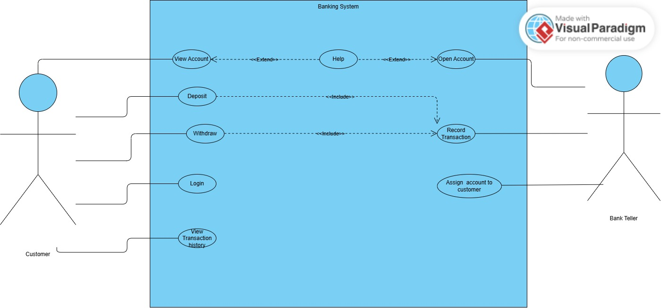

**Class Diagram**

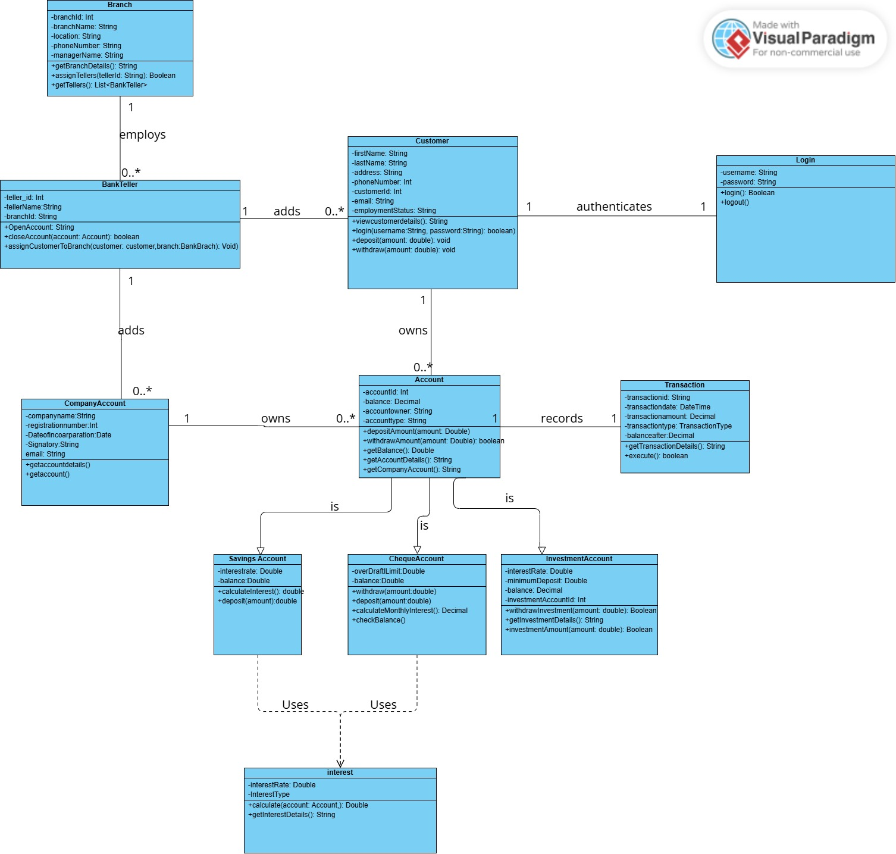

**Behavioural UML Modelling**

**Login sequence diagrams**

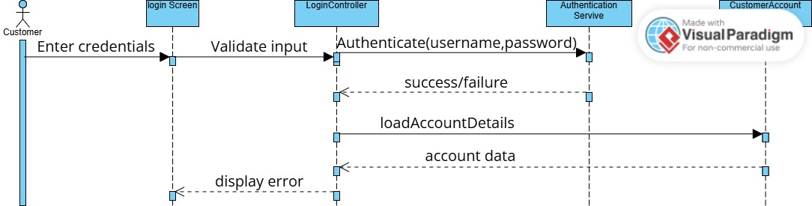

**Deposit Sequence Diagram**

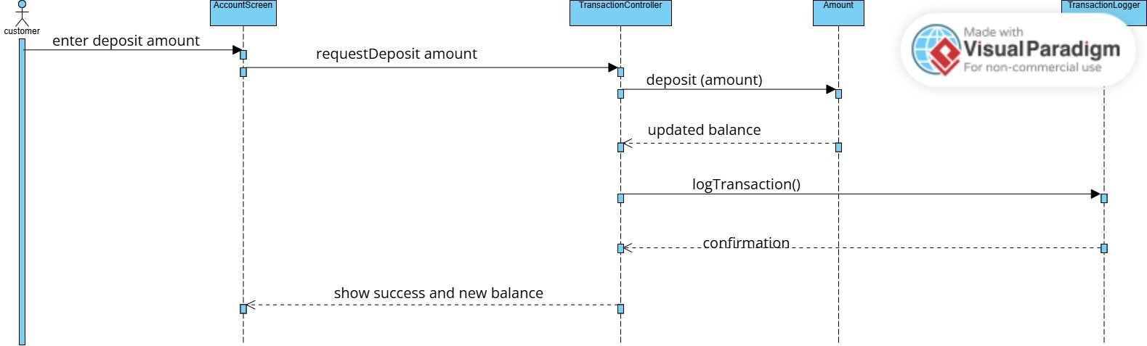

State Diagram

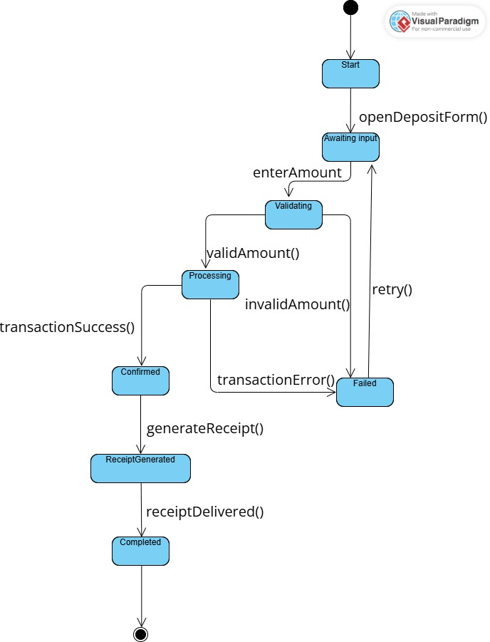

**Interview Record**

**Project:** Banking System  
**Date:** 18 September 2025  
**Venue:** Online  
**Interviewer:** Kago Junior Gopelomang  
**Interviewee:** Kentsenao Baseki

**Agenda**

1. Gather functional and non-functional requirements for the banking system
2. Clarify account rules and interest logic
3. Define usability, performance, and security expectations